Tehnički fakultet u Boru
Univerzitet u Beogradu



Naslov seminarskog rada

Profesor: Studenti:
Doc. dr Darko Brodić Ime i prezime, br. indeksa

Asistent: Smer:
Ime i prezime asistenta Naziv smera

Bor, mesec godina.
NASLOV (primeni stil M_Title)

Izvod: This is Abstract section. One paragraph only (primeni stil M_abstract).

Ključne reči: keyword, keyword (primeni stil M_abstract).

Abstract: Tekst engleski (primeni stil M_abstract).

Keywords: engleske ključne reči (primeni stil M_abstract).

Uvod (primeni stil M_Heading1 Format)

Text (primeni stil M_Text).

Poglavlje 1 (primeni stil M_Heading1 Format)

Text (primeni stil M_Text).

Poglavlje 2 (primeni stil M_Heading1 Format)

Text (primeni stil M_Text).

Poglavlje 3 (primeni stil M_Heading1 Format)

Text (primeni stil M_Text).

Podpoglavlje (primeni stil M_Heading2 Format)
Tekst (primeni stil M_Text).

ZAKLJUČAK (Apply M_Heading1 Format)

Tekst (primeni stil M_Text).

Naslov tabele (primeni stil M_Tablecaption).
(primeni stil M_Table).

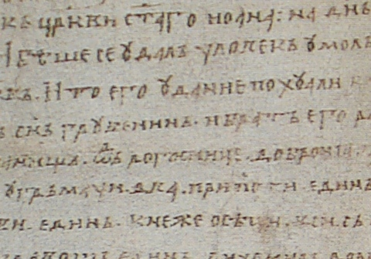
Slika 1. Dokument (primeni stil M_Figure)

ZAHVALNICA

Tekst (primeni stil M_Text format).

LITERATURA

- D. Buddhasukh, J. R. Cannon, B. W. Metcalf and A. J. Power, " Synthesis of 5-n-alkylresorcinol dimethyl ethers and related compounds via substituted thiophens", Aust. J. Chem., 1971, 24, 2655-2664. (Apply M_Refer style).
- A. I. Vogel, "A Textbook of Practical Organic Chemistry", 3rd Edn., Longmans, London, 1956, pp. 130-132.
- W. Leistritz, "Methods of bacterial reduction in spices ", in "Spices: Flavor Chemistry and Antioxidant Porperties" (Ed. S. J. Risch and C-T. Ito), American Chemical Society, Washington, DC, 1997, Ch. 2.
- W. phutdhawong, “Isolation of glycosides by electrolytic decolourisation and synthesis of pentinomycin”, PhD Thesis, 2002, Chiang Mai University, Thailand.
- P. M. Sears, J. Peele, M. Lassauzet and P. Blackburn, "Use of antimicrobial proteins in the treatment of bovine mastitis", Proceedings of the 3rd International Mastitis Seminars, 1995, Tel-Aviv, Israel, pp. 17-18.
- Reference list (Apply M_Refer style).
- S. Simon, “What is an odds ratio?”, 2008, http://www.childrensmercy.org/stats/definitions/or.htm (Accessed: October 2011).

